**Arduino**

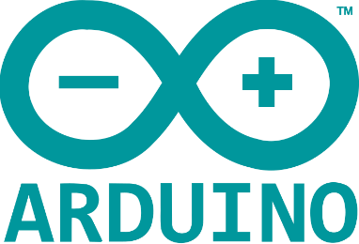Arduino is an open-source electronics platform based on e easy-to-use hardware and software.

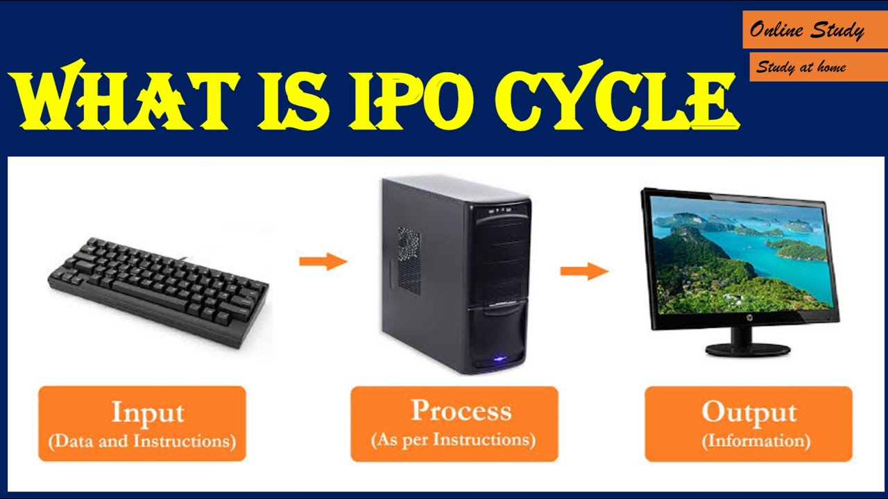**Input -> CPU -> Output**

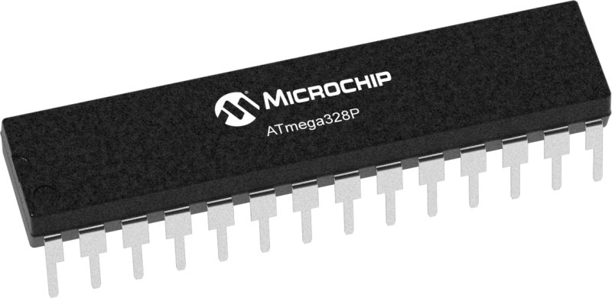

The Arduino Microcontroller uses the ATmega 328p as its brain. ATmega328P is a high performance yet low power consumption 8-bit AVR microcontroller that's able to achieve the most single clock cycle execution of 131 powerful instructions thanks to its advanced RISC architecture. It can commonly be found as a processor in Arduino boards such as Arduino Fio and Arduino Uno.

**Microprocessor VS Microcontroller**

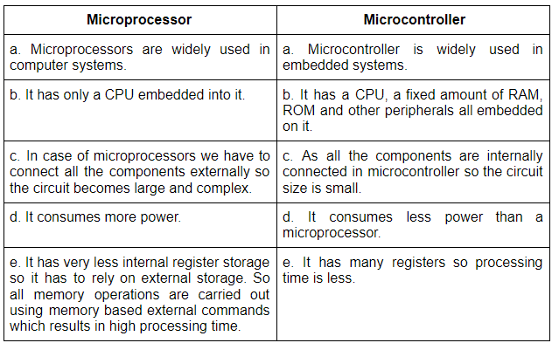

**Arduino Uno Board**

